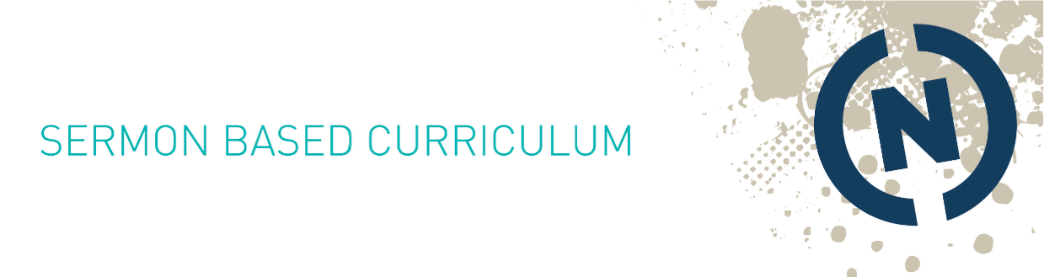
Date & Sermon Series:
April 18/19, 2015; One Little Yes
Speaker:
Pastor Mark Batterson
Scripture Focus: Acts 8:26
Note To Leaders:
This weekend we discussed saying “yes” to the promptings of the Holy Spirit. These questions provide a framework to prompt or foster discussion. Don’t feel you have to use all or any of these questions and you don’t have to make it to the end! Use the questions that best fit your group and let discussion flow.
Icebreaker Suggestions: Pastor Mark shared about seeing an epitaph that said, “World’s greatest cornetist.” What would you like your epitaph to say you’re the “world’s greatest” of?
Sermon Series Questions:
- What thoughts are still resonating with you from the sermon?
- What was most encouraging or challenging about this weekend’s message?
- To what in your life do you need to say “one little yes?”
Specific Questions:
- Is there anything you feel prompted to start but haven’t yet taken the leap? If so, why haven’t you? What needs to happen for you to do so?
- Pastor Mark stated that, “the hardest part of any endeavor is getting to the starting line.” Do you relate to this statement? Why or why not?
- Zechariah 4:10 states, “do not despise these small beginnings, for the Lord rejoices to see the work begin….” Are there small beginnings in which you need to rejoice? If not now, can you remember a time of small beginnings that grew? What was the outcome of those small beginnings?
- Have you ever obeyed the promptings of the Holy Spirit and stepped out? What happened when you did?
- Do you relate to the idea that, “we want God to reveal the second step before we take the first step, but sometimes we have to take the first step in faith.” Describe a time you had to take that first step of faith and the outcome of your obedience.
- When describing the process of buying 205 F St, Pastor Mark stated that, “Some things you don’t need to pray about; you just need to say ‘yes’ because the Holy Spirit has already spoken on the matter.” Does this ring true for you? If so, how?
- What do you need to stop doing to go from good to great? What is your barren fig tree that is wasting your time and energy, and what needs to take its place? What does God have that’s better?
Challenge:
Read & Pray: Pray through Acts 8:26 and reflect on what promptings of the Holy Spirit you need to respond to.
Act: Pastor Mark shared that while the first time is always the hardest, delayed obedience is disobedience and inaction is an action. He also encouraged us not to wait because there is no better time than the present! Let today be the day you take that first small step in obedience to the promptings you’re receiving from the Holy Spirit.

